**What is a SERVO?**

A Servo is a small device that incorporates a two wire DC motor, a gear train, a potentiometer, an integrated circuit, and an output shaft. Of the three wires that stick out from the motor casing, one is for power, one is for ground, and one is a control input line. The shaft of the servo can be positioned to specific angular positions by sending a coded signal. As long as the coded signal exists on the input line, the servo will maintain the angular position of the shaft. If the coded signal changes, then the angular position of the shaft changes.

A very common use of servos is in Radio Controlled models like cars, airplanes, robots, and puppets. They are also used in powerful heavy-duty sail boats. Servos are rated for Speed and Torque. Normally there are two servos of the same kind, one geared towards speed (sacrificing torque), and the other towards torque (sacrificing speed). A good example of this is the HS-625MG servo and the HS-645MG servo.

Servos come in different sizes but use similar control schemes and are extremely useful in robotics. The motors are small and are extremely powerful for their size. It also draws power proportional to the mechanical load. A lightly loaded servo, therefore, doesn’t consume much energy.

A typical Servo looks like a rectangular box with a motor shaft coming out of one end and a connector with three wires out of the other end. The three wires are the power, Control, and Ground. Servos work with voltages between 4 and 6 volts. The control line is used to position the servo. The servo motor comes in different sizes, which affect the overall size of the servo. The gears of a servo vary from servo to servo. Inexpensive servos have plastic gears, and more expensive servos have metal gears which are much more rugged but wear faster. The potentiometer of a servo is the feedback device. The electronics of a servo are pretty much the same in all servos, but the output shaft bearing of a servo has either a plastic on plastic bearing that will not take much side load or a metal on metal bearings that stand up better under extended use, or ball bearings which work best. We highly recommend ball bearing servos if your application demands heavy side loads.

Servos are constructed from three basic pieces; a motor, a potentiometer (variable resister) that is connected to the output shaft, and a control board. The potentiometer allows the control circuitry to monitor the current angle of the servo motor. The motor, through a series of gears, turns the output shaft and the potentiometer simultaneously. The potentiometer is fed into the servo control circuit and when the control circuit detects that the position is correct, it stops the motor. If the control circuit detects that the angle is not correct, it will turn the motor the correct direction until the angle is correct. Normally a servo is used to control an angular motion of between 0 and 180 degrees. It is not mechanically capable (unless modified) of turning any farther due to the mechanical stop build on to the main output gear.

The amount of power applied to the motor is proportional to the distance it needs to travel. So, if the shaft needs to turn a large distance, the motor will run at full speed. If it needs to turn only a small amount, the motor will run at a slower speed. This is called proportional control.

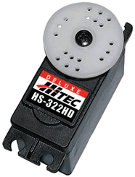

http://www.servocity.com/assets/images/Hitec_Gear_Banner.jpg

We offer four different gear materials in our Hitec line of servos. Nylon is the base and is great for standard applications and offers excellent wear resistance to keep the gear mesh tight for years. Karbonite is 4 times stronger than Nylon and offers even better wear resistance and super quiet operation. Standard Metal is perfect for rugged applications and is 16 times stronger than Nylon but will wear much faster. Our Titanium gears are simply awesome. Virtually, no wear after years of use and 48 times stronger than Nylon gears. If your application is critical and you cannot afford a gear failure, Titanium is the way to go.

http://www.servocity.com/assets/images/Neodymium_Motor_Magnets.jpg

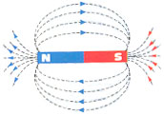

Ever wonder how Hitec packs so much power into these little servo cases? All of their cored servo motors use incredibly strong Neodymium rare earth magnets. Neodymium magnets are also known as “supermagnets” so it’s worth the little extra cost for the increased performance gained from using these magnets. In the “servo world” you get what you pay for.

**How does a SERVO work?**

The purpose of this information is to give an overview of how servos operate and how to communicate with them. Though we have taken steps to assure the quality of information here, ServoCity makes no guarantees about the information presented. ServoCity cannot be held liable or accountable for any use or misuse of the provided information. If you have questions about this information please e-mail tech@servocity.com

Servos are controlled by sending them a pulse of variable width. The control wire is used to send this pulse. The parameters for this pulse are that it has a minimum pulse, a maximum pulse, and a repetition rate. Given the rotation constraints of the servo, neutral is defined to be the position where the servo has exactly the same amount of potential rotation in the clockwise direction as it does in the counter clockwise direction. It is important to note that different servos will have different constraints on their rotation but they all have a neutral position, and that position is always around 1.5 milliseconds (ms).

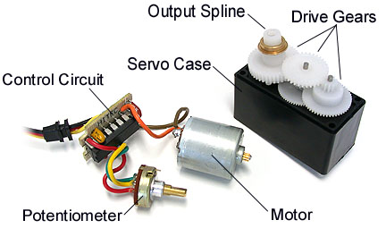

The angle is determined by the duration of a pulse that is applied to the control wire. This is called Pulse width Modulation. The servo expects to see a pulse every 20 ms. The length of the pulse will determine how far the motor turns. For example, a 1.5 ms pulse will make the motor turn to the 90 degree position (neutral position).

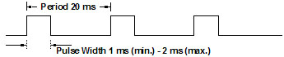

When these servos are commanded to move they will move to the position and hold that position. If an external force pushes against the servo while the servo is holding a position, the servo will resist from moving out of that position. The maximum amount of force the servo can exert is the torque rating of the servo. Servos will not hold their position forever though; the position pulse must be repeated to instruct the servo to stay in position.

When a pulse is sent to a servo that is less than 1.5 ms the servo rotates to a position and holds its output shaft some number of degrees counterclockwise from the neutral point. When the pulse is wider than 1.5 ms the opposite occurs. The minimal width and the maximum width of pulse that will command the servo to turn to a valid position are functions of each servo. Different brands, and even different servos of the same brand, will have different maximum and minimums. Generally the minimum pulse will be about 1 ms wide and the maximum pulse will be 2 ms wide.

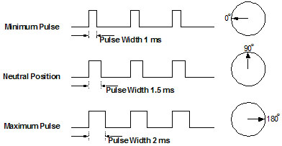

Another parameter that varies from servo to servo is the turn rate. This is the time it takes from the servo to change from one position to another. The worst case turning time is when the servo is holding at the minimum rotation and it is commanded to go to maximum rotation. This can take several seconds on very high torque servos.

**SERVO Terminology**

**Coreless Motor** - This refers to the armature of the motor. A conventional servo motor has a steel core armature wrapped with wire that spins inside the magnets. In a coreless design, the armature uses a thin wire mesh that forms a cup that spins around the outside of the magnets eliminating the heavy steel core. This design results in smoother operation and faster response time.

**Indirect Drive** - This refers to the potentiometer inside the servo. The final output shaft (the part that the horn/arm attaches) has to be supported not only near the end but also deep inside the servo case. Indirect drive is when the final output shaft is not dependent on the potentiometer for support inside the gear case. Normally a bushing or bearing supports the load. Direct Drive is when the potentiometer plays a supporting role in holding the output shaft in place. Most sub-micro servos are direct drive since they are tight on space and do not have the room for an extra bushing or bearing.

**Spline** - This is the output shaft of the servo. It is what you attach the servo horns or arms to. Standard Hitec splines are 24 tooth with standard Futaba splines 25 tooth.

**Transit Time** - This is the amount of time is takes for the servo to move a set amount, usually rated at 60 degrees. Example: A servo with at transit time of .19 sec. to 60 degrees would mean that is takes the servo nearly 1/5th of a second to rotate 60 degrees.

**Torque** - This is the maximum power the servo can produce. It is normally rated in inch-ounces. This means that the servo can move this set amount with a 1” arm attached to the output shaft or spline. Example: A servo with a torque rating of 130 in.-oz. can move that amount with a 1 inch arm or slightly over 8 lbs. To convert in-oz. to pounds of force, divide this rating by 16. Example: 130/16=8.125 which is in pounds.

**3 or 5 Pole Motors**- This refers to the commutator in the motor. The commutator is where the brushes make contact with the armature. The more motor poles the smoother and more accurate the servo will operate. Most servos have either 3 or 5 pole commutators.

**Nylon Gears** - Nylon gears are most common in servos. They are extremely smooth with little or no wear factors. They are also very lightweight. If your application calls for long duration but not jarring motion, nylon gears are a top choice.

**Karbonite Gears** - Karbonite gears are relatively new to the market. They offer almost 5 times the strength of nylon gears and also better wear resistance. Cycle times of well over 300,000 have been observed with these gears with virtually no wear. Servos with these gears are more expensive but what you get in durability is more than equaled.

**Metal Gears** - Metal gears have been around for sometime now. They offer unparalleled strength. With a metal output shaft, side-loads can be much greater. In applications that are jarred around, metal gears really shine. There are two cons to metal gears, weight and wear. First, metal gears are much heavier than both nylon and karbonite gears. Second, metal gears wear several times that of nylon gears. How quickly depends on the loads that you place on the servo. They will eventually develop a slight play or slop in the gear-train that will be transferred to the spline. It will not be much but accuracy will be lost at some point.

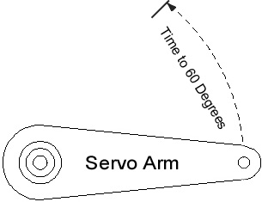**SERVO Speed and Power**

**Servo Speed**

Servo speed is stated in seconds. Just as a car has a 0-60 mph time, a servo has a 0-60 degree time. The lower the 60 degree time the faster the servo operates.

**SERVO Power**

Servo power is stated as ounce-inches (oz-in.) This is the maximum amount of power the given servo will apply with a one inch arm. For example, if a servo has a power rating of 16 oz-in, the maximum amount of power it will be able to apply with a 1” arm will be 1 lbs.  
  
If you are needing to find out how many pounds a servo will lift or push with a 1” arm, simply divide the oz-in. number by 16.

Servo speed is stated in seconds. Just as a car has a 0-60 mph time, a servo has a 0-60 degree time. The lower the 60 degree time the faster the servo operates.

**oz-in. / 16 = pounds of force (1” arm)**

you are planning on using a 2” arm, you will then need to divide the pounds of force once again by 2.

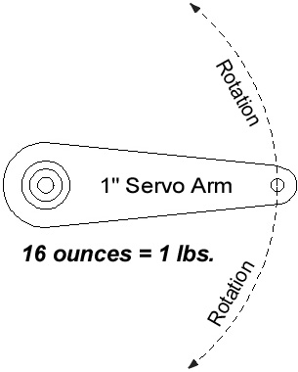**Example:**  
An HS-425BB has 57 oz-in. of power  
57 divided by 16 = 3.56  
3.56 would be the pounds of force with a 1” arm  
  
If you were to put on a 2” arm on the HS-425BB:  
3.56 / 2 = 1.78  
1.78 would be the pounds of force with a 2” arm  
  
If you were to put on a 3” arm on the HS-425BB:  
3.56 / 3 = 1.18  
1.18 would be the pounds of force with a 3” arm

SERVO Direction Information

All servos will rotate clockwise and counterclockwise. The direction the servo rotates all depends on the signal the servo is receiving. Futaba and Hitec are different from one another in regards to direction of rotation right out of the box. If you plug in a Hitec servo into your radio control receiver or servo controller and you tell the servo to turn to the right, it will move to the right, if you then plug a Futaba servo into the same receiver or servo controller and tell it to go the same direction as the Hitec servo did, it will move the opposite direction. This is an easy fix with most radio control units since they have a servo reversing function on the transmitter. If you are using a servo controller though and are mixing Hitec and Futaba servos it may cause a problem. This problem can easily be fixed but not as easy as flipping a switch on a transmitter. This is why under the “specification” section for each servo we list the direction of rotation as either clockwise or counter clockwise.

**SERVO Connection Type**

**All of our Hitec servos come with the “S” or universal connector. This connector works with any brand of receiver, servo controller or servo extension.**

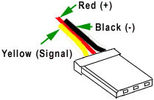

**Note:** This pug can be accidentally plugged into a receiver in reverse. If this happens, no damage will occur, the servo will simply will not work. If you receive a servo and it does not work, make sure that you have plugged it in correctly.

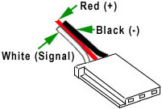

All of our Futaba servos come with the “J” or Futaba connector. This connector has a guide on the side of the plastic plug. This connector will not work with Hitec, JR or Airtronic Z or T servo extensions.

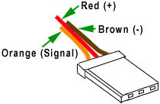

JR plugs are the exact same as the Hitec “S” connectors. If you are ordering servos or extensions for your JR system, the universal connectors are what you need.

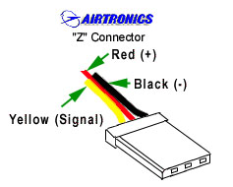

Airtonic “Z” plugs are the exact same as the Hitec “S” connectors. If you are ordering servos or extensions for your Airtronics Z system, the universal connectors are what you need.

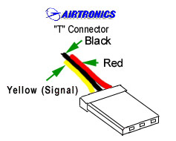

Airtronic “T” plugs are no longer manufactured. If you have old Airtronic servos, they may have this connector. The positive and negative pin locations are reversed from the plugs above. If you attempt to plug this older style into a new style receiver, you will damage either the receiver or the servo. If you want to update your old servos to the new style, make sure to reverse the pin locations to match the above.

**180˚ Rotation**

When controlled with a radio control system, most hobby servos offer 90° (45° either direction) rotation right out of the box. This can sometimes be increased if your radio system offers end point adjustments or your servo controller has a 180° jumper pin. If you are using Hitec digital servos, you simply want to purchase the hand-held programmer to increase the rotation. If you have a Hitec or Futaba analog servo that only offers 90° of rotation, the amount of rotation can sometimes be increased to 180° by performing a simple modification.

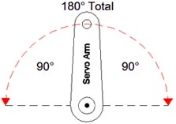

**Note:** You can purchase Hitec servos from us that are pre-modified in our own manufacturing facility on the individual Hitec servo pages. **This modification voids all ServoCity and Hitec warranties.**

**Continuous Rotation Information**

When building a robot or a wheeled platform, servos can often be used to drive wheels. In many instances, servos offer better power and are more compact than comparable motors and come with an electronic “speed control” (H-bridge) already attached to control the speed and direction of rotation. Once this modification is performed, your servo will operate as an “open loop” system. This means that the feedback from the potentiometer will be disconnected. The servo will now operate like a gearmotor with a speed control attached to control the speed and direction of rotation. You will be able to control it forward and reverse proportionally.

Not all servos are the same when it comes to modifying them for continuous rotation. We have devised a [**Continuous Modification Difficulty List**](http://www.servocity.com/html/rotation_modification_difficul.html)to help you choose the best and the easiest Hitec servos to modify. Some micro servos have a “half pie” shaped final gear that allows the servo case to be very compact but also means that they cannot be modified for continuous rotation. Others have the final gear resting directly on top of the potentiometer which means the potentiometer can not be removed and yet others need to have the final gear drilled out. Soon we will have a detailed list that will take you through each Hitec servo that can be modified to allow to you make the best choice that matches your skill level.

**Note:** You can purchase Hitec servos from us that are pre-modified in our own manufacturing facility on the individual Hitec servo pages. **This modification voids all ServoCity and Hitec warranties.**